**DAILY ONLINE ACTIVITIES SUMMARY**

|  |  |  |  |  |  |  |  |  |
| --- | --- | --- | --- | --- | --- | --- | --- | --- |
| **Date:** | **2 June 2020** | | | | | **Name:** | **Sana F Habib** | |
| **Sem & Sec** | **6th sem & B sec** | | | | | **USN:** | **4AL17CS081** | |
| **Online Test Summary** | | | | | | | | |
| **Subject** | | **CGV** | | | | | | |
| **Max. Marks** | | **30** | | **Score** | | | **28** | |
| **Certification Course Summary** | | | | | | | | |
| **Course** | **Career Edge** | | | | | | | |
| **Certificate Provider** | | | **TCS** | | **Duration** | | | **15 days** |
| **Coding Challenges** | | | | | | | | |
| **Status: Executed** | | | | | | | | |
| **Uploaded the report in Github** | | | | | **YES** | | | |
| **If yes Repository name** | | | | | [**https://github.com/sanahabib2409199/Sana-F-H.git**](https://github.com/sanahabib2409199/Sana-F-H.git) | | | |
| **Uploaded the report in slack** | | | | | **YES** | | | |
|  | | | | |  | | | |

Online Test Details: (Attach the snapshot and briefly write the report for the same)

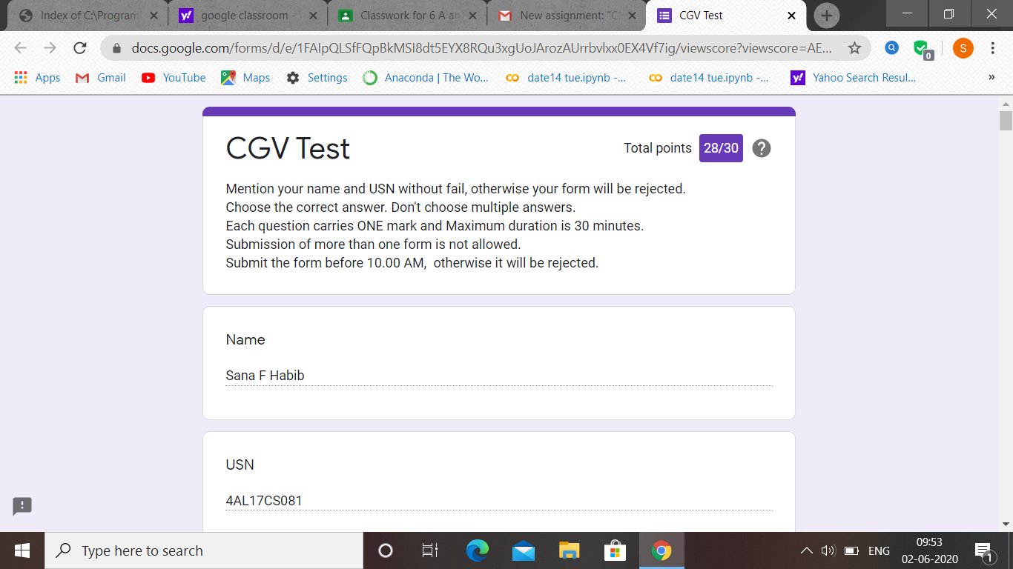

CGV test was held today in google classroom i.e 2 June 2020. Out of 30 marks I scored 28.

Certification Course Details: (Attach the snapshot and briefly write the report for the same

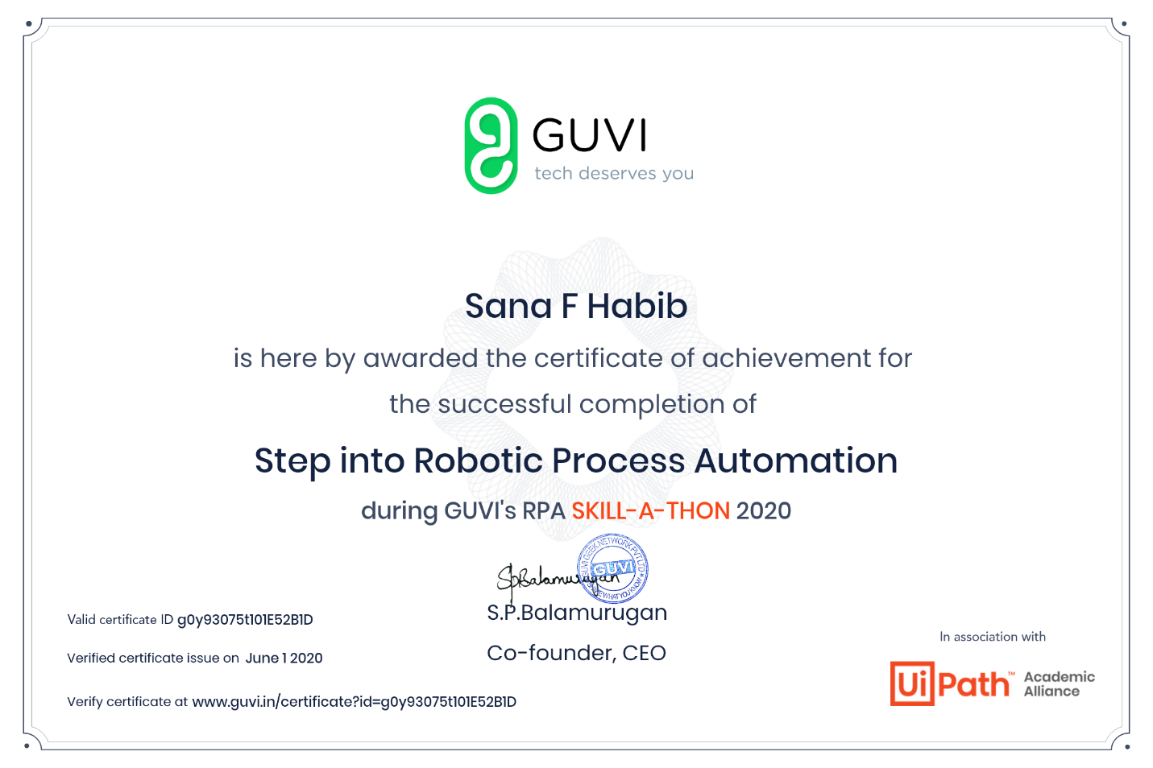

(2-06-2020)-RPA.

Coding Challenges Details: (Attach the snapshot and briefly write the report for the same)

Program 1

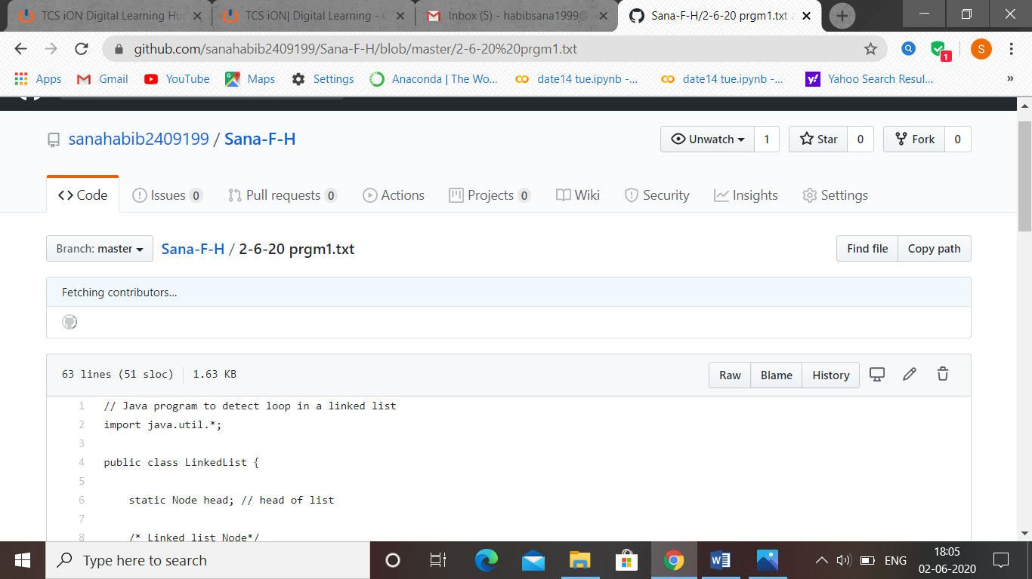

Program 2

